A SUGGESTED REINTERPRETATION OF PSYCHOSYNTHESIS

RELATIVE TO

THE COMPLETE LIFE CYCLE AS INTERPRETED BY KEN WILBER

Anett B. Wannamaker, Ph.D.

Abstract

Presents an alternate view of Psychosynthesis in the upper realms of the Inward Arc to that presented by Ken Wilber in his comparative study of psychologies and religions, The Atman Project (1980). Proposes a placement of the Higher Self in the High and Low Causals so as to touch on the High Subtle. Also contests Wilber’s placement of the collective higher unconscious between the personal higher unconscious and the Higher or Transpersonal Self, and argues that when seen in a linear fashion, the Transpersonal Self of Psychosynthesis must be seen as lying in between the two states of consciousness.

To my knowledge, no one has yet to question Ken Wilber’s placement of Psychosynthesis’ Higher Self (1980, p. 180) on the Inward Arc of The Complete Life Cycle (ibid., p. 5). I would like to offer an alternative.

Wilber’s Life-Cycle view of Psychosynthesis
In his Life-Cycle view of Psychosynthesis in The Atman Project (1980), Wilber offers a set of survey and summary tables (pp. 178-184), in which he orders a variety of developmental theories and practices within the Life Cycle. Superimposed on the Life Cycle (ibid., p. 5), his Table-3 overview of Psychosynthesis (ibid., p. 180) would appear as illustrated in Figure 1:

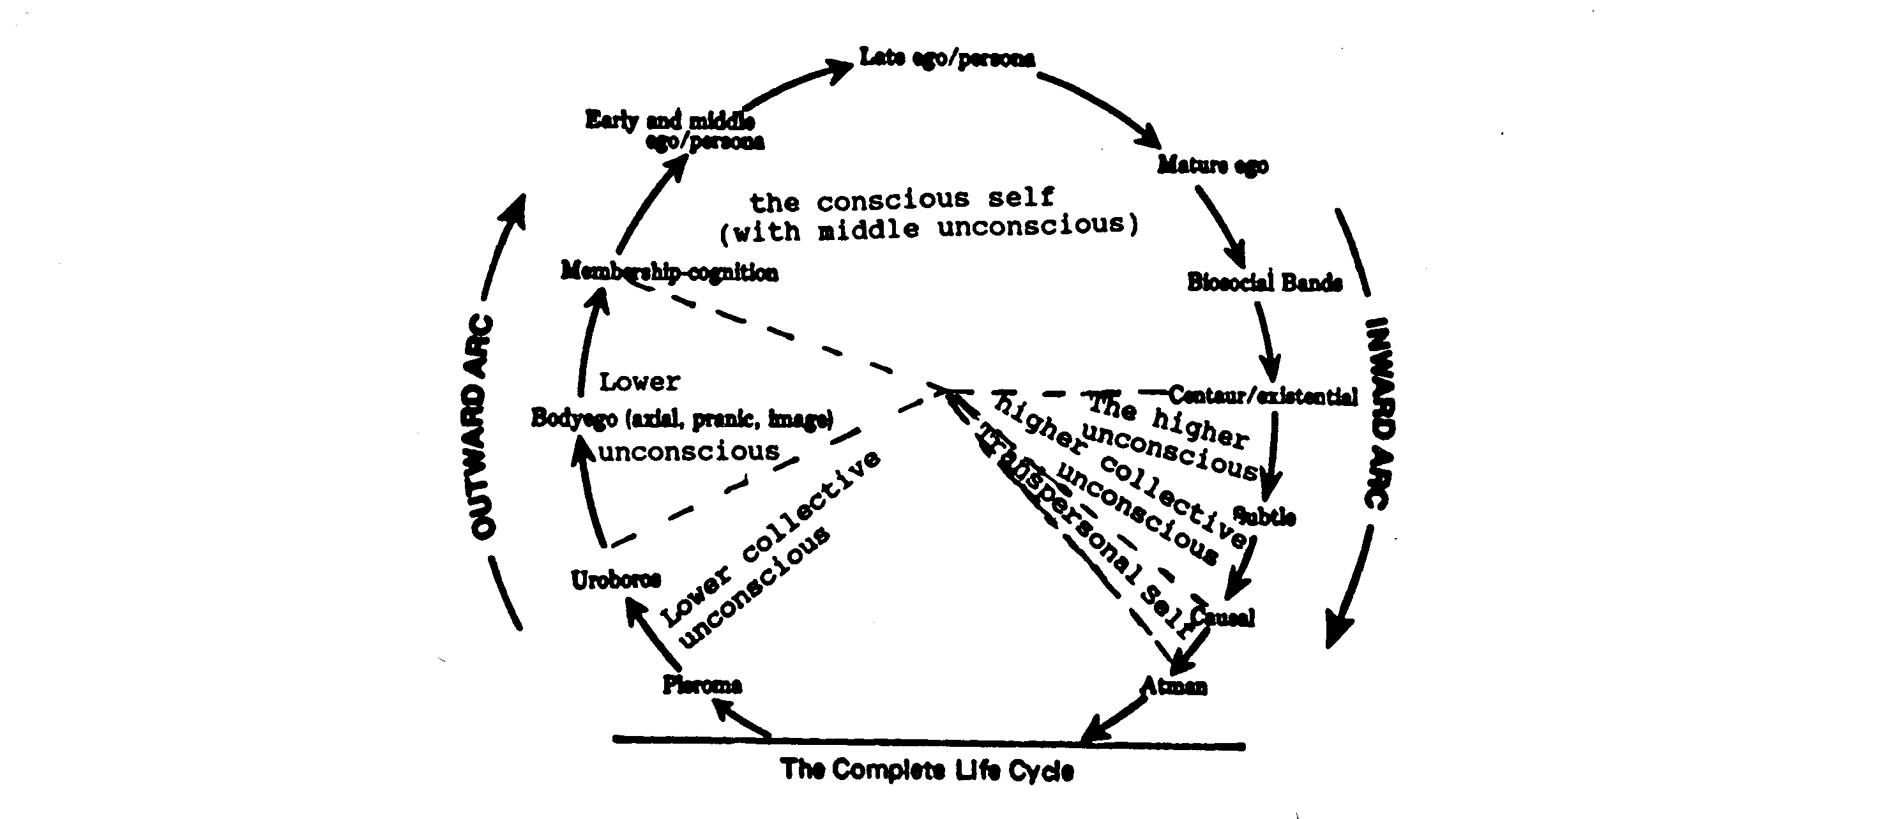
Psychosynthesis as interpreted by Ken Wilber
Figure 1

Note that in Wilber’s interpretation, the collective higher unconscious is placed between the personal higher unconscious and the Higher or Transpersonal Self.

Basis for disagreement
From my reading of Roberto Assagioli (1965, 1973, and P.R.F. Issue No. 19), Wilber’s placement of the collective higher unconscious between the personal higher unconscious and the Higher Self appears as a clear misunderstanding. Although Assagioli warns against making and “‘entity’ of the unconscious” (P.R.F. Issue No. 19, p. 8), and considers “the unconscious” to be “an adjective, not a noun” (ibid., his italics), his egg-diagrammatic model of human consciousness (Figure 2) places the Higher or Transpersonal Self at the apex of the personality so as to touch the personal higher unconscious or superconscious. The collective unconscious is noted outside the diagram of the personality (ibid.), with the lines of the diagram dotted to suggest permeable boundaries between the personal and collective states of consciousness (1965, p. 19). The “‘star’... is partially outside the periphery of the individual psyche, and partially within it” (P.R.F. Issue No. 19, p. 16), and “in my diagram of the constitution of the psyche, the collective unconscious is represented as lying outside the individual psyche. The demarcation line is dotted, to suggest the continuous exchanges going on between the collective and the personal unconscious” (ibid., p. 8).

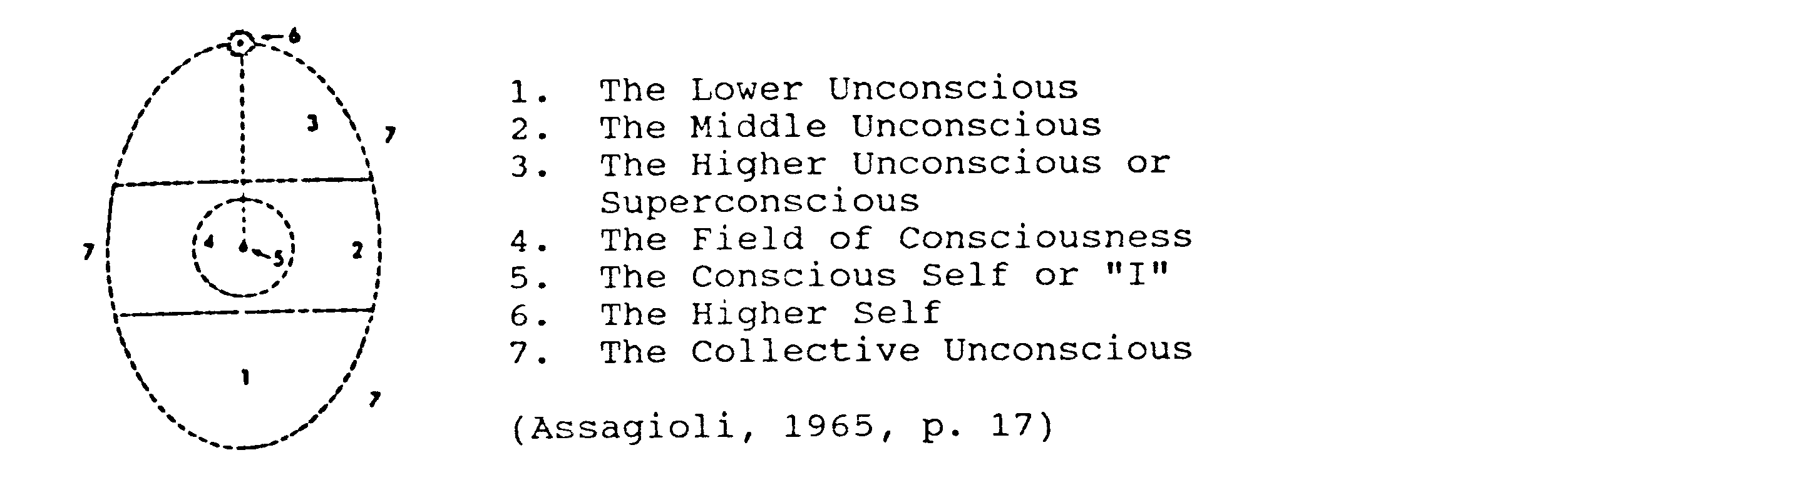
Psychosynthesis’ View of Human Consciousness
Figure 2

Based on Assagioli’s diagram (Figure 2) and his above elaboration of it, it is clearly a mistake to place the personal higher unconscious closer to the collective higher unconscious than to the Transpersonal Self as does Wilber in his placement of Psychosynthesis in the Complete Life Cycle. The Transpersonal Self is contained both within the personal and the collective unconscious (P.R.F. Issue No. 19, p. 16). As a part of both, it might be perceived as a link between the two. When seen in a linear fashion, the Transpersonal Self must therefore be seen as lying in between the two superconscious states, not separated from one by the other.

Procedure for development of an alternate view
To correct Wilber’s Table-3 and the Complete-Life-Cycle view of Psychosynthesis for Assagioli’s own interpretation, I suggest that we first turn to Assagioli’s discussion of Psychosynthesis and Abraham Maslow’s psychology. Based upon this, I offer the suggestion that Wilber’s Life-Cycle representation of Psychosynthesis be reinterpreted to coincide with Wilber’s assessment of Maslow’s psychology (1980, p. 181).

Maslow’s “SELF-realization concerns the... superconscious, and pertains to Transpersonal or spiritual psychosynthesis,” writes Assagioli (1973, p. 121, his emphasis). It has three stages. The first stage is “the activation and expression of the potentialities residing in the superconscious” (ibid.). The second stage is “the direct awareness of the SELF, which culminates in the unification of the consciousness of the personal self, or ‘I’, with that of the Transpersonal Self” (ibid., pp. 121- 122, his italics). Assagioli here suggests that Maslow’s Self realization or transcendence might be likened to Spiritual Psychosynthesis, and that the three terms, Maslow’s Self-realization and transcendence and Assagioli’s Spiritual Psychosynthesis, all pertain to identical realms of the Inward Arc.

Wilber places Psychosynthesis’ personal higher unconscious – the superconscious – in the High and Low Subtle realms of the Complete Life Cycle. Assagioli might have limited it to the Low Subtle as the first realm of Self-realization: “The superconscious precedes consciousness of the Self” (Assagioli, 1965, p. 198). According to Wilber’s definition, the self mode of the High-Subtle Self is “archetypal-divine, over-self, over-mind” (1980, p. 69). I interpret that to mean Self consciousness. But Wilber’s placement of the personal superconscious may be viewed as correct if we allow an overlap of the superconscious and the Transpersonal Self in the High Subtle realm.

Wilber’s restriction of the Transpersonal Self to the High Causal and Ultimate realms (ibid., p. 180), however, is not correct in light of Assagioli’s discussion. As the second stage of Self-realization or Spiritual Psychosynthesis, Self awareness follows immediately upon the awakening of the superconscious energies. And, if my interpretation of Wilber is correct, Self consciousness begins in the High Subtle realm. Assagioli also understands the Transpersonal Self to be a “point” “within the Universal Self” (1973, pp. 260-261), the Atman in Wilber’s terminology. Clearly, then, Assagioli assigns to Psychosynthesis’ Higher or Transpersonal Self a much wider spectrum of functioning within the Complete Life Cycle than that suggested by Wilber (1980, p. 180). Conscious awareness of the Transpersonal Self appears, in Assagioli’s description (1973, pp. 121-122), to cover the whole upper range of the Inward Arc, beginning with the High Subtle. Such an interpretation would also coincide with Wilber’s Life-Cycle placement of Maslow’s Self-realization and Transcendence.

Wilber’s Life-Cycle view of Abraham Maslow’s psychology
In Wilber’s Table-4 illustration of Maslow’s psychology (1980, p. 181), Self-realization or transcendence covers the entire upper area of the Inward Arc of the Life Cycle beginning with the Low Subtle realm. Superimposed on The Complete Life Cycle (ibid., p. 5), Maslow’s psychology would then appear as in Figure 3:
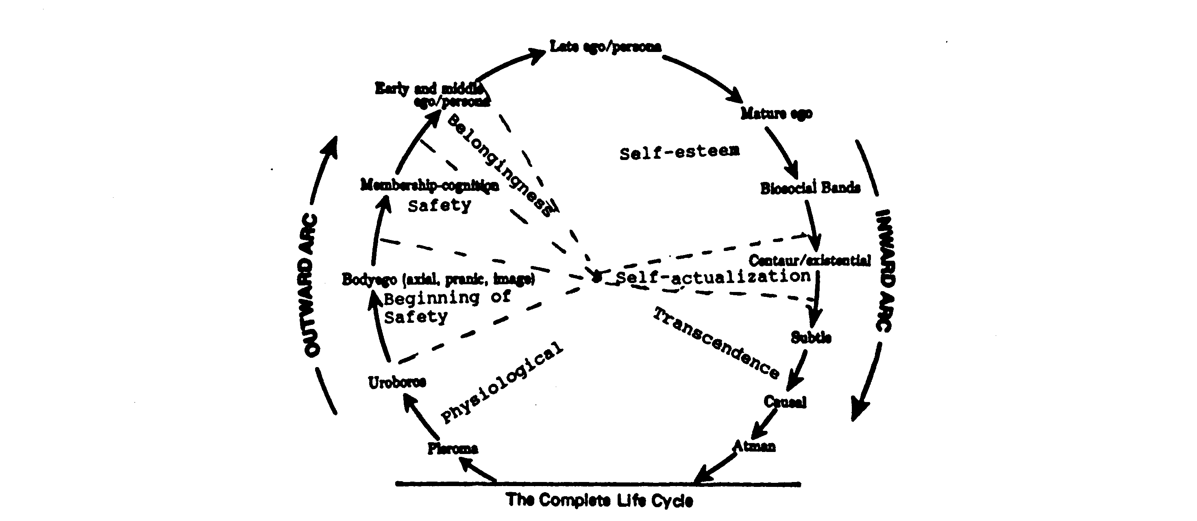
Abraham Maslow’s psychology as interpreted by Ken Wilber
Figure 3

An alternate Life-Cycle view of Psychosynthesis
Keeping in mind the dynamic nature and range of activity of the Higher or Transpersonal self as the “synthesizing center” of the personality (Assagioli, 1965, p. 19) and the mediator between the personal and Universal Selves (Assagioli, 1973, p. 18), as well as Assagioli’s egg-diagrammatic placement of the Transpersonal Self relative to the superconscious and collective unconscious (1965, p. 17: P. R. F. Issue No. 19, p. 16 and ibid., p. 8) (Figure 2), I propose the placement of the Higher or Transpersonal Self in the High and Low Causals, so as to touch on the High Subtle realms of Wilber’s Complete Life Cycle (1980, p. 5).

Superimposed on Wilber’s Life Cycle and adapted according to my understanding of Psychosynthesis and Assagioli’s suggested relationship between his and Maslow’s psychologies (1973, pp. 120-122), Psychosynthesis would then appear as in Figure 4 below. The dotted lines suggest the dynamic nature of the personality as suggested by Assagioli (1965, p. 19).

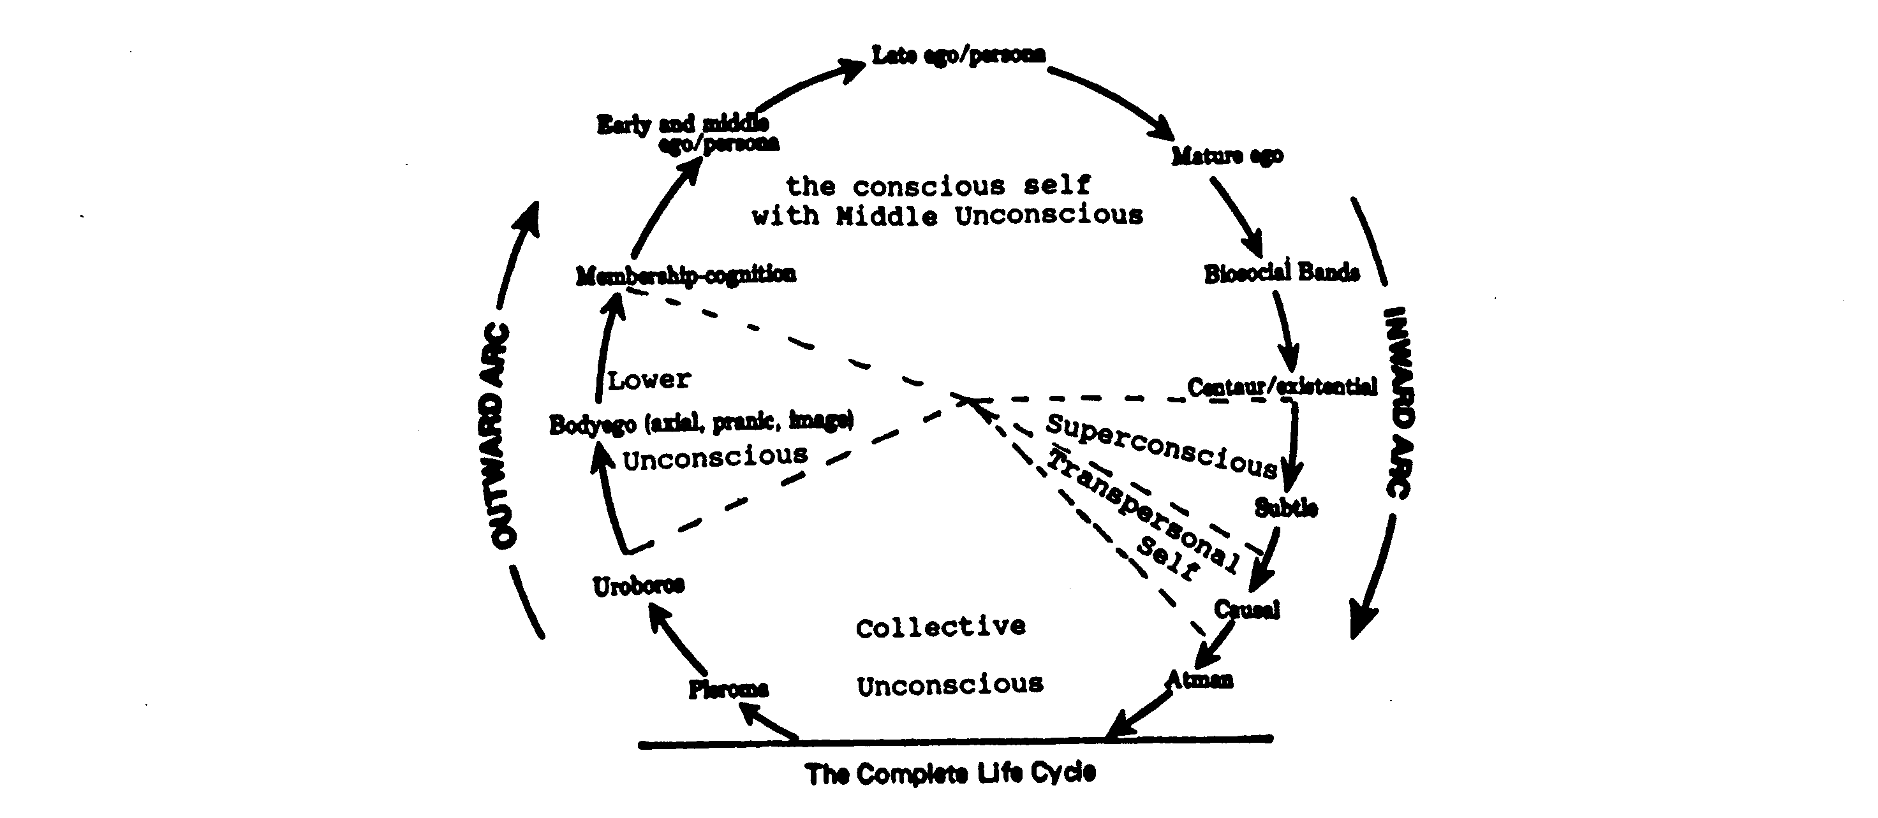
Reinterpretation of Psychosynthesis relative to Ken Wilber’s Complete Life Cycle
Figure 4

Significance
Wilber’s presentation of Psychosynthesis, which represents a serious departure from that of Assagioli’s, has consequences both for Higher-Self understanding and for the understanding of consciousness.

First, Assagioli understands the Higher Self as “a permanent center” of the personality (1965, p. 18), a “true Self situated beyond or ‘above’” the conscious self (ibid.). As the permanent center of the personality, it is “above, and unaffected by, the flow of the mind-stream or by bodily conditions” (ibid., p. 19) and responsible for the “re-appearance of the conscious self” or ‘I’ after sleep, hypnoses or anaesthetic (ibid., p. 18). In other words, the Higher Self as Assagioli understands it, is intimately connected to the conscious self. The conscious self might be understood as the Higher-Self’s reflection, “‘its projection’ in the field of the personality” (ibid., p. 19). The collective unconscious, on the other hand, represents the “psychic environment” (ibid.) of the personality. It is the “‘body’ to which the ‘cell,’” which is individual psychological life, belongs (ibid.). Wilber’s interpretation, then, blurs the distinction, which Assagioli makes between the individual psyche and its environment. In addition, it serves to distance the personality from what Assagioli perceives as its center. Wilber thereby presents a Psychosynthesis view of human consciousness, which is very different from that presented by Assagioli.

Secondly, the Higher Self is the “synthesizing center” of the personality (Assagioli, 1965, p. 19) as well as its link to Ultimate Reality (Assagioli, 1973, p. 127). As “a point” in the Universal Self (Assagioli, 1973, p. 260-261), the Transpersonal Self might be thought of as that which in religious terms might be referred to as “God in man/woman,” their groundedness in God or the Universal Self. This “point”, writes Assagioli, is not in itself God or the transcendent Reality; for transcendent Reality, men and women must look beyond the Higher Self (ibid., p. 127). And to describe transcendent Reality – the Universal Self – the Atman – Assagioli turns to the religious traditions (ibid., pp. 128-131).

Assagioli understands the Higher or Transpersonal Self as that part of men and women which can reach out to and link them to transcendent Reality (ibid., p. 127), and the Transpersonal Self itself is found within, not beyond the personality.

In order that the transpersonal community might receive the full benefits of Psychosynthesis and Roberto Assagioli’s contribution to “height” or Inward-Arc psychology, Wilber’s interpretation of Psychosynthesis should be corrected to coincide with that of its founder.

References

Assagioli R. (1965). Psychosynthesis, a Manual of principles and techniques. New York: Viking. (1973). The Act of Will. Baltimore: Penguin Books.
Psychosynthesis Research Foundation. (Undated). Jung and Psychosynthesis. (P.R.F. Issue No. 19). New York: R. Assagioli.
Wannamaker, A. B. (1989). A Psychosynthesis Study of Agnes Sanford’s Practice and Theology of Prayer Healing. Unpublished doctoral dissertation. Institute of Transpersonal Psychology, Palo Alto, CA.
Wilber, K. (1980). The Atman Project, A Transpersonal View of Human Development. Wheaton, IL: Theosophical Publishing House.

